This Photo by Unknown Author is licensed under CC BY
Dental hygiene is just as important for dogs as it is for humans. Good dental care can help your dog maintain healthy teeth and gums, prevent bad breath, and avoid more serious health problems down the line. Here are some reasons why dental hygiene is important for dogs:
- Prevention of tooth decay and gum disease: Dogs, just like humans, can develop tooth decay and gum disease if their teeth are not properly cared for. These conditions can be painful and can even lead to tooth loss if left untreated.
- Prevention of bad breath: One of the most noticeable signs of poor dental hygiene in dogs is bad breath. Regular teeth cleaning and dental care can help keep your dog's breath fresh and prevent unpleasant odours.
- Prevention of infections and other health problems: Poor dental hygiene in dogs can lead to infections and other health problems that can affect their overall well-being. These can include abscesses, inflammation, and even heart disease.
- Improved overall health: Good dental hygiene can also help improve your dog's overall health and quality of life. By preventing dental problems, your dog can avoid pain and discomfort, eat comfortably, and enjoy a better quality of life.
To ensure good dental hygiene for your dog, it's important to provide regular teeth cleaning and check-ups with your veterinarian, as well as feed them a fresh food diet. By prioritising your dog's dental care, you can help ensure they stay healthy and happy for years to come.
How do we maintain clean teeth and fresh breath for our dogs and cat?
We have four steps to maintaining good dental hygiene for our pets and avoiding unnecessary surgery.
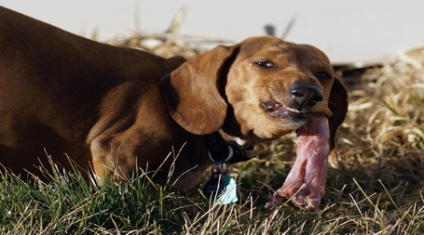
This Photo by Unknown Author is licensed under CC BY

- Fresh meaty bones
- Fresh meaty bones can be beneficial for a dog's dental hygiene. When dogs chew on bones, it can help to scrape away plaque and tartar build up on their teeth. However, it's important to choose the right type of bones and supervise your dog while they're chewing to ensure their safety. Here are some tips to keep in mind:
- Choose raw bones.
- NEVER give cooked bones, as they splinter and cause life threatening harm to your dog's digestive system.
- Select the right size. Choose a bone that is appropriate for your dog's size and breed. Large, weight-bearing bones (like beef femurs) are not recommended, as they can be too hard and can break your dog's teeth. Instead, choose softer bones, such as poultry and rabbit; wings, feet, carcases or necks. Veal, pork, and lamb ribs are also a good option.
- Source bones from a reputable supplier: Make sure you get bones from a reputable supplier, preferably one that sources the bones from grass-fed, free-range animals.
- Monitor your dog. Always supervise your dog while they're chewing on a bone. If you notice any signs of difficulty, remove the bone immediately.
By following these tips, you can safely provide your dog with fresh bones that can help promote dental hygiene, as well as provide a natural and enjoyable source of entertainment and nutrition.

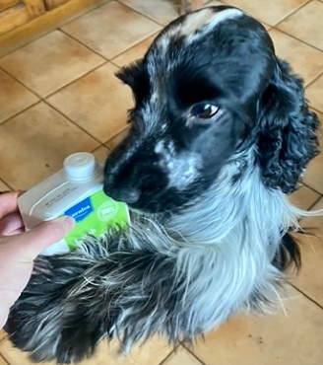
- Bone broth
- Bone broth can provide many benefits for dogs, including dental benefits. Bone broth is made by simmering animal bones, such as beef , lamb or chicken, for an extended period of time, which releases many beneficial nutrients, minerals, and collagen that can help support a dog's overall health.
- One dental benefit of bone broth is that it can help to keep a dog's teeth clean. When a dog drinks bone broth, it's the minerals and nutrients in the broth can help to remove plaque and tartar build-up on their teeth, similar to how chewing on bones can help to clean teeth.
- Make sure your bone broth is from a reputable supplier, preferably one that sources the bones from grass-fed, free-range animals.
- We use and recommend Karnlea Bone Broth; check out their website for details www.karnlea.com, like and follow them on social media, as they often have great offers and discount codes to take advantage of.
- When feeding bone broth to your dog, it's important to use a recipe that is safe and appropriate for dogs. Some human bone broth recipes may include ingredients that are harmful to dogs, such as onions and salt.

- Appropriate crunchy treats to help remove plaque

Barnaby’s Fish Skins 100% Fish Skins and 100% Cod Skin Bites

- Our fish skins are made from dried cod and are a popular treat for dogs, they offer a number of benefits in comparison to other types of fish skins. Dried cod fish skins are high in omega-3 fatty acids, which are beneficial for dogs' overall health, including their coat and skin, joints, and immune system.
- When it comes to dental health, cod fish skins help remove plaque and tartar from dog's teeth. The skins are tough and chewy, which help scrape away plaque build-up and promote healthy gums. The act of chewing also helps to stimulate saliva production, which can help clean the teeth and neutralize harmful bacteria in the mouth.
Barnaby’s Dental Fish Skin
- Our dental fish skins have been dried with hand-harvested local seaweed proven to remove plaque from dogs teeth.
- The seaweed we hand-harvest has been the subject of some scientific research as a natural remedy for dental health in dogs.
- The seaweed has anti-plaque properties due to a compound called fucoidan. Fucoidan has antibacterial and anti-inflammatory properties, which helps to reduce the amount of bacteria in the mouth and prevent inflammation of the gums.
- A study published in the Journal of Animal Physiology and Animal Nutrition in 2014 found that the addition of our seaweed to dogs' diets reduced the amount of plaque on their teeth.
- We are currently working with Munster University to conduct our own scientific research project on the seaweed that we use and the additional benefits of adding it to cod fish skins.
- You can buy our fish skins directly from our online shop www.barnabyspets.co.uk, or one of our stockists, listed on our website.
By incorporating these key factors into your dog's routine, you can help to improve their dental hygiene and promote overall health and wellbeing.

Poor dental health can lead to a variety of health issues and illnesses in dogs. Here are some examples:
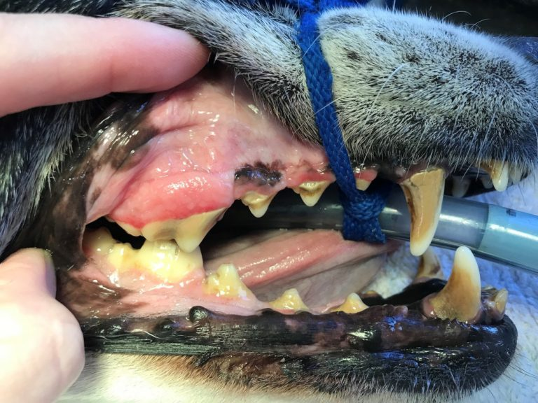
This Photo by Unknown Author is licensed under CC BY-NC-ND
- Periodontal Disease: This is a bacterial infection that affects the gums and tissues surrounding the teeth. It can cause painful inflammation, tooth loss, and can even spread to other parts of the body, leading to more serious health issues.
- Oral Abscesses: Poor dental hygiene can lead to the development of painful oral abscesses, which are pockets of pus that form in the mouth. This can cause significant pain and discomfort for the dog, and may require surgical intervention to treat.
- Kidney Disease: Poor dental hygiene has been linked to the development of kidney disease in dogs. This is because the bacteria that are present in the mouth can enter the bloodstream and cause damage to the kidneys over time.
- Heart Disease: Poor dental hygiene has also been linked to the development of heart disease in dogs. This is because the bacteria that are present in the mouth can enter the bloodstream and travel to the heart, causing inflammation and damage to the heart valves.
- Respiratory Infections: Bacteria from the mouth can also enter the respiratory system, causing infections such as pneumonia and bronchitis.
Overall, it's clear that maintaining good dental hygiene in dogs is essential for their overall health and wellbeing.

