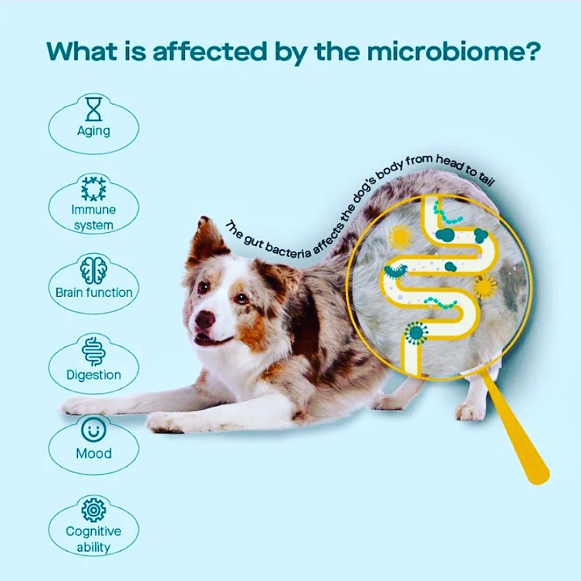

The Importance of a Diverse Gut Microbiome in Your Dog

Unlocking the Secrets to a Healthy and Happy dog

A blog post by Barnaby’s Happy Healthy Pets

The Importance of a Diverse Gut Microbiome in Your Dog
Just like in humans, your dog's gut health is a fundamental cornerstone of their overall well-being. The gut microbiome is a complex community of microorganisms residing in your dog’s digestive tract and plays a pivotal role in their health and vitality.

A diverse gut microbiome is essential for ensuring your furry companion's optimal health and happiness.

Here's why:

Digestive Health
A diverse gut microbiome is crucial for your dog's digestion. The various bacteria present in the microbiome help break down food into nutrients that your dog's body can absorb. This efficient digestion promotes better nutrient absorption and leads to improved energy levels and overall vitality.

Strong Immune System
Did you know that a significant portion of your dog's immune system resides in their gut? A diverse microbiome helps regulate the immune response, teaching it to differentiate between harmless substances and potential threats. This balanced immune function protects your dog from infections, allergies, and autoimmune conditions.

Nutrient Production
Certain bacteria within the gut microbiome can produce essential nutrients, such as vitamins B and K. These nutrients are vital for your dog's health and contribute to functions like blood clotting and energy production.

Mental and Emotional Well-being
Believe it or not, your dog's gut health can influence their mood and behaviour. The gut-brain connection means that a balanced microbiome can positively impact your dog's temperament, promoting a calmer and happier disposition.

Weight Management
A diverse gut microbiome may contribute to your dog's weight management. Research suggests that the composition of the microbiome is linked to metabolism and weight regulation. A balanced microbiome helps your dog maintain a healthy weight.

Allergy and Sensitivity Prevention
An imbalanced gut microbiome can contribute to allergies and food sensitivities in dogs. A diverse microbiome helps build tolerance to various substances, reducing the risk of adverse reactions.

Disease Prevention
A thriving gut microbiome plays a role in preventing certain diseases and conditions, including gastrointestinal disorders, obesity, and even some types of cancer.

Adaptability to Diet Changes
A diverse gut microbiome enables your dog to handle changes in their diet more effectively. It supports the digestion of different types of foods, making dietary transitions smoother.

Longevity and Quality of Life
When your dog's gut is healthy, it positively impacts their entire body. A diverse microbiome contributes to a longer, healthier, and more enjoyable life for your furry friend.

Follow these tips to ensure diversity of your dog’s microbiome:

Balanced Diet
Feed your dog high-quality, fresh, species appropriate food with a variety of protein sources and fibre-rich ingredients such as vegetables and fruits, as these nourish beneficial microbes.

Probiotics
Incorporate probiotic-rich foods like yogurt and kefir into their diet.

Prebiotics
Include foods rich in prebiotic fibres, like kale, courgette, cottage cheese and seaweeds to nourish beneficial gut bacteria.

Fresh Water Make sure your dog has access to clean, fresh water at all times. Hydration is essential for a healthy gut.

Bone broth
Bone broth is a nutrient rich, tasty gravy to add to your dog’s daily routine to support the immune system and the microbiome.

Limit antibiotics and other medications
Only use antibiotics and other medications when necessary, as they disrupt the gut microbiome's delicate balance.

Use natural parasite treatments.
Natural parasite meal toppers not only deter bugs from landing on and biting your dog, but they also have microbiome boosting herbs and botanicas in their ingredients.

Titre test in place of annual boosters
Titre testing allows you, as the dog owner, to see if your dog needs to receive the booster or not. This reduces the need for unnecessary vaccinations that will harm the microbiome.

Here are some factors that can reduce a dog's microbiome diversity:

Several factors can reduce a dog's microbiome diversity, potentially disrupting the balance of beneficial and harmful microorganisms in the gut. It's important for dog owners to be aware of these factors to help maintain their furry friend's gut health.

Antibiotic Use: Antibiotics are designed to target and eliminate bacteria, both harmful and beneficial, that may be causing an infection. While antibiotics are essential for treating bacterial infections, their use disrupts the natural balance of the gut microbiome.

Poor Diet
Feeding a dog an unbalanced or poor-quality diet can negatively impact their gut health. A processed diet lacking in variety and essential nutrients leads to a less diverse microbiome. Highly processed foods and diets low in protein and fibre limit the types of bacteria that thrive in the gut.

Stress
Stress can affect dogs just as it does humans. Events such as changes in routine, loud noises, or unfamiliar environments can trigger stress responses that influence the gut microbiome. Stress can lead to changes in gut motility, blood flow, and the release of certain hormones that impact microbial balance.

Infections and Illnesses
Certain infections and illnesses, especially those affecting the digestive system disrupt the microbiome. Diarrhoea, vomiting, and other gastrointestinal issues alter the composition of the gut bacteria.

Environmental Factors
Exposure to environmental toxins, pollutants, and chemicals impact the health of a dog's gut microbiome. These substances have antimicrobial effects that alter the balance of microorganisms in the gut.

Age
As dogs age, their gut microbiome will naturally shift. Puppies typically have less diverse microbiomes, which develop and become more stable as they mature. However, age-related changes impact on the diversity and balance of gut bacteria.

Medications and Treatments
Certain medications, such as nonsteroidal anti-inflammatory drugs (NSAIDs) and chemotherapy affect the gut microbiome. Additionally, toxic treatments for flea and tick control indirectly impact the microbiome through oral ingestion or skin absorption.

Lack of Exercise
Physical activity influences gut health and microbiome diversity. Dogs that lead a sedentary lifestyle will have a less diverse microbiome compared to those with regular exercise.

Overuse of Disinfectants
Excessive use of disinfectants and cleaning products in the dog's environment will reduce exposure to natural microbes that contribute to a healthy microbiome.

Insufficient Hydration
Adequate water intake is essential for maintaining gut health. Dehydration impacts digestion and alters the gut microbial community.

*To help maintain a diverse and healthy gut microbiome in your dog, focus on providing a balanced diet, managing stress, and minimising unnecessary antibiotic use.

So how can nutrition impact on your dog’s microbiome diversity?

Nutrition's Impact on Microbiome Diversity in Dogs
The saying "You are what you eat" holds true not only for humans but also for our canine companions. Nutrition plays a critical role in shaping the health of your dog's gut microbiome. A balanced and diverse diet has a profound impact on the composition and richness of the microbiome, leading to various health benefits.

Here's how nutrition influences microbiome diversity in dogs:

Promoting Beneficial Bacteria
A diet rich in prebiotic fibres provides nourishment to beneficial bacteria in the gut. These fibres are not fully digested by your dog's enzymes but are instead fermented by certain bacteria, leading to the production of short-chain fatty acids (SCFAs). SCFAs contribute to a healthier gut environment and encourage the growth of beneficial microbes.

Probiotics and Fermented Foods
Adding probiotics (live beneficial bacteria) to your dog's diet, either through naturally fermented foods like yogurt, kefir, and fermented dog safe vegetables, directly introduce diversity into the gut microbiome. These beneficial bacteria help populate the gut with health-promoting microbes.

Protein Sources
A varied protein intake diversifies the types of bacteria that thrive in your dog's gut. Different protein sources provide distinct amino acids and nutrients, supporting the growth of various microbial species. This diversity contributes to a resilient and balanced microbiome.

Microbial Nutrient Needs
The food your dog consumes provides the nutrients that various microorganisms in their gut rely on for growth and activity. A diverse diet rich in different nutrients ensures that a wide range of beneficial bacteria can flourish. These bacteria contribute to a balanced microbiome.

Avoiding Overly Processed Foods
Highly processed dog foods that lack natural ingredients and nutrients limit microbiome diversity. Feed fresh, species appropriate diets to provide a wider array of nutrients for your dog's microbiome.

Hydration
Proper hydration supports digestion and nutrient absorption, contributing to a healthier gut environment. Ensure your dog has access to clean, fresh water at all times.

Managing Weight and Metabolism
The types of nutrients your dog consumes influence their metabolism and body weight. A balanced diet can help regulate these factors, potentially preventing obesity and related health issues.

Mitigating Inflammation
A diet rich in antioxidants and anti-inflammatory nutrients can help reduce inflammation in the gut. Chronic inflammation can disrupt the microbiome and lead to imbalances.

Addressing Food Sensitivities
Some dogs may have sensitivities or allergies to certain ingredients. Identifying and eliminating these triggers from their diet can lead to relief from digestive issues and a healthier microbiome.

Maintaining Gut Barrier Integrity
Certain nutrients contribute to the health of the gut lining, helping maintain the barrier between the gut and the rest of the body. A well-maintained barrier prevents harmful substances from entering the bloodstream and maintains microbiome balance.

Transitioning Diet Gradually
When making changes to your dog's diet, it's essential to do so gradually to give their microbiome time to adjust. Rapid changes can disrupt the balance of the microbiome and lead to digestive upset.

Antibiotics and Medications
While antibiotics are sometimes necessary, their use can disrupt the balance of the gut microbiome. Whenever possible, follow your veterinarian's guidance on antibiotic use, and consider incorporating probiotics during and after antibiotic treatment to help restore microbiome diversity.

Conclusion
Nutrition plays a pivotal role in shaping the diversity and health of your dog's gut microbiome. Providing a varied and balanced diet, rich in fibre, prebiotics, and beneficial bacteria, supports the growth of a diverse microbial community. A thriving and diverse microbiome enhances digestion, strengthens the immune system, and contributes to your dog's overall well-being. Prioritise your dog's nutritional needs to ensure a healthy and vibrant life.

